**ANALYZING THE VIDEOGAME SALES DATASET**

**PRATIK GURAM**

**RUID 196004669**

**Introduction:** The following project is based on analyzing the videogame sales dataset which contains data till 2016 and can be used to arrive at various conclusions based on the needs of the user enterprise. I have used Python on Jupyter Notebook to visualize the data and better explain the data in layman’s terms, which in turn would help allow the user to decide on their further course of action. I have used Exploratory Data Analysis as the base, as I’m inclined to allow human intuition to get the better of machine analysis, as I believe at least right now, we can better understand the circumstances around a situation and arrive at a conclusion.

**Abstract:** As far as the videogame industry is concerned, according to Microsoft, there are more than two billion gamers around the world. This number includes everyone from those playing free games on their phone to those using a state-of-the-art computer fitted with the latest hardware. And the gaming market is only growing. By 2022, experts forecast the gaming industry will produce $196 billion in revenue. It's no wonder then that tech giants like Apple and Google are trying to cash in by launching gaming streaming services. Because tech giants like Google and Apple are foraying into the videogame industry, the companies already in the race need to keep up with the transitioning trends of videogame genres. Video games have even challenged the definition of sports, as we watch teenage competitors become more popular than professional athletes. Esports revenue is expected to surpass $1 billion for the first time this year, according to NewZoo. Video games are not only influencing the business market but also the social structure of the society and its impact can be observed throughout the world.

The dataset is a web scrape of VGChartz Video Game Sales, and this data set simply extends the number of variables with another web scrape from Metacritic.

The dataset is easily available on Kaggle for future referencing and data visualizations to be applied to.

The dataset being used contains Name, Platform, Year of Release, Genre, Publisher, NA Sales, EU Sales, JP Sales, Other Sales, Global Sales along with the following fields,

* Critic score - Aggregate score compiled by Metacritic staff
* Critic count - The number of critics used in coming up with the Critic score
* User score - Score by Metacritic's subscribers
* User count - Number of users who gave the user score
* Developer - Party responsible for creating the game
* Rating - The ESRB ratings

**Mathematical Modelling:**

**UNIVARIATE ANALYSIS:**

* For analyzing this dataset, Univariate and Bivariate Analysis are the techniques being used.
* Univariate analysis is the simplest form of statistical analysis which, like other statistical techniques, can be inferential or descriptive.
* Descriptive statistics describe a sample or population. They can be part of exploratory data analysis.
* The appropriate statistic depends on the level of measurement. For nominal variables, a frequency table and a listing of the modes is enough. For ordinal variables, the median can be calculated as a measure of central tendency and the range (and variations of it) as a measure of dispersion. For interval level variables, the arithmetic mean(average) and standard deviation are added to the toolbox and, for ratio level variables, we add the geometric mean and harmonic mean as measures of central tendency and the coefficient of variation as a measure of dispersion.
* For interval and ratio level data, further descriptors include the variable’s skewness and kurtosis.

**BIVARIATE ANALYSIS:**

* Bivariate analysis is also one of the simplest forms of statistical analysis. It involves the analysis of two variables (often denoted as *X*, *Y*), for the purpose of determining the empirical relationship between them.
* Bivariate analysis can be helpful in testing simple hypotheses of association. Bivariate analysis can help determine to what extent it becomes easier to know and predict a value for one variable (possibly a dependent variable) if we know the value of the other variable (possibly the independent variable).
* Bivariate analysis can be contrasted with univariate analysis in which only one variable is analyzed. Like univariate analysis, bivariate analysis can be descriptive or inferential. It is the analysis of the relationship between the two variables.

**EXPLORATORY DATA ANALYSIS:**

* Exploratory data analysis (EDA) is an approach to analyzing data sets to summarize their main characteristics, often with visual methods. A statistical model can be used or not, but primarily EDA is for seeing what the data can tell us beyond the formal modeling or hypothesis testing task.
* The objectives of EDA are to:
* Suggest hypotheses about the causes of observed phenomena.
* Assess assumptions on which statistical inference will be based.
* Support the selection of appropriate statistical tools and techniques.
* Provide a basis for further data collection through surveys or experiments.
* The presence of more than a single variable or parameter and their relationship.
* Simplest form of statistical analysis makes it easier to explain.
* OR is quantifying the relevance of a variable to your outcome (dependent variable), while P-value is simply quantifying statistical significance (or not) of the relationship you are currently analyzing (basically acknowledging the outcome was unlikely to have occurred by chance alone). Really two different perspectives.
* The odds ratio gives you the size of the effect and the p value gives you the probability that your result is due to chance.

**ANALYSIS:**

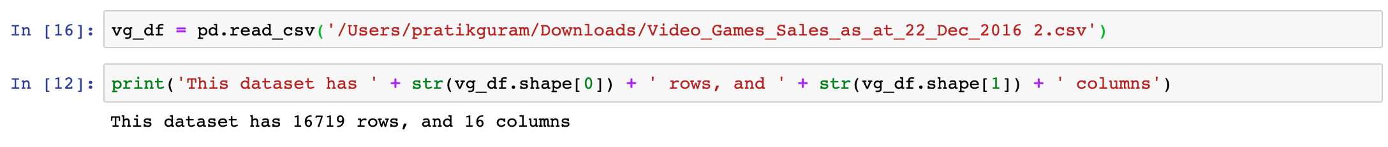

First, check the size of the dataset.

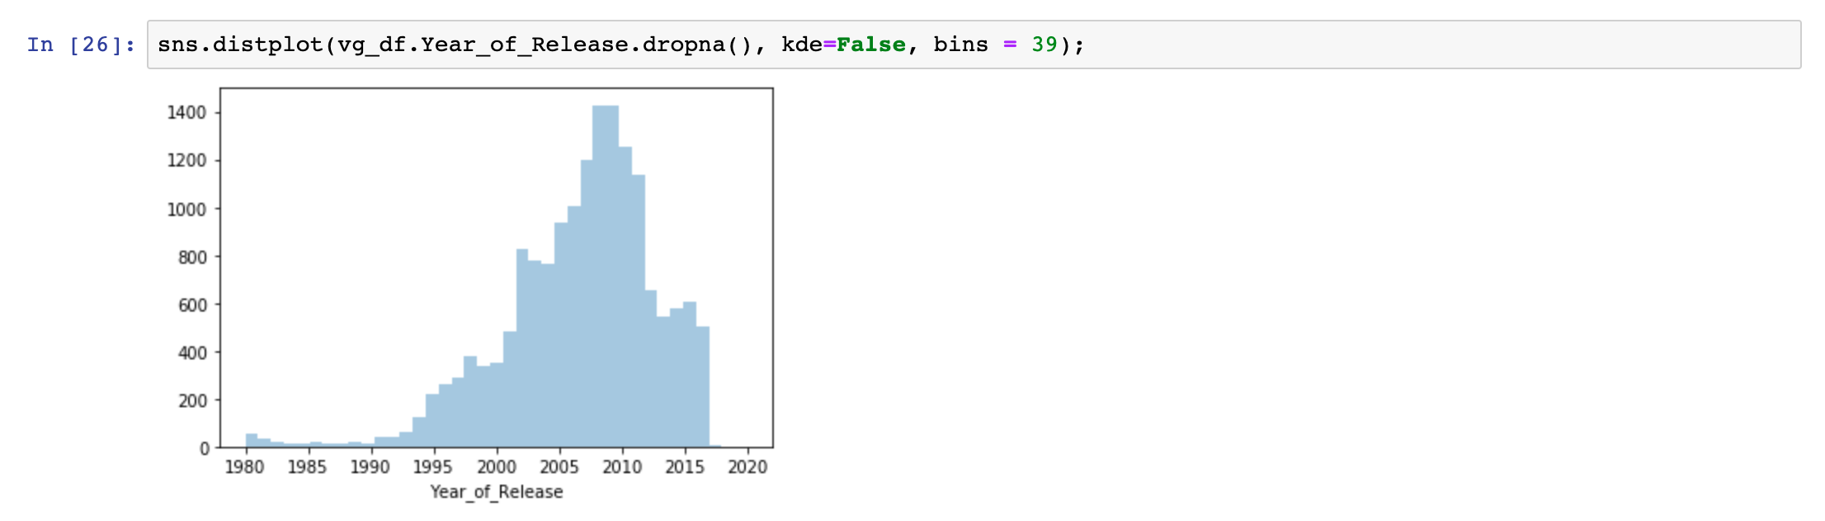

Then we check the skew of the year of release of the videogames. We find that there is a negative skew in the graph and that after 2009, there was a sharp drop in the number of releases. I found out that 2009 was the year of recession, and this was the major factor.

Then we plot the Global sales, North America sales, European Union sales, Japan sales and Rest of the world sales.

Also included is a whisker plot for each of these sales.

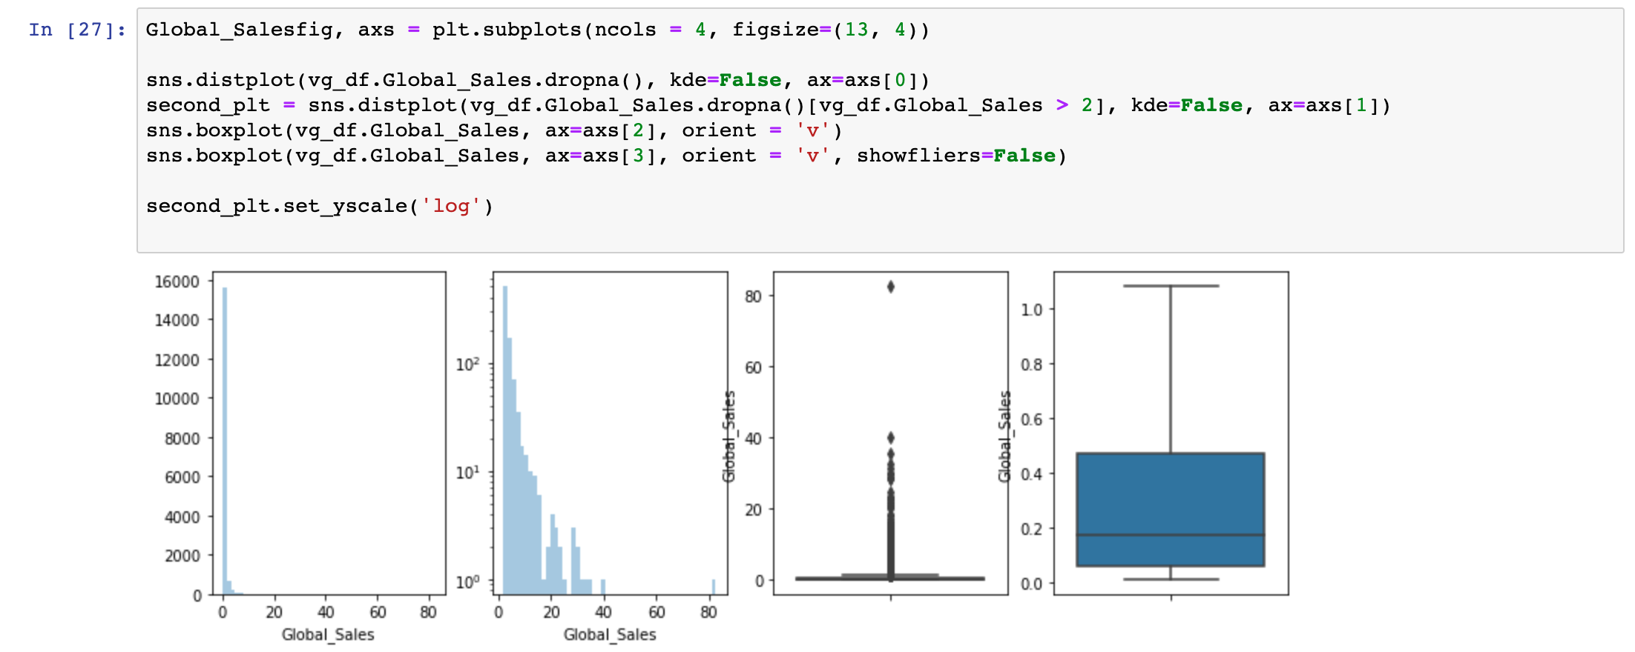

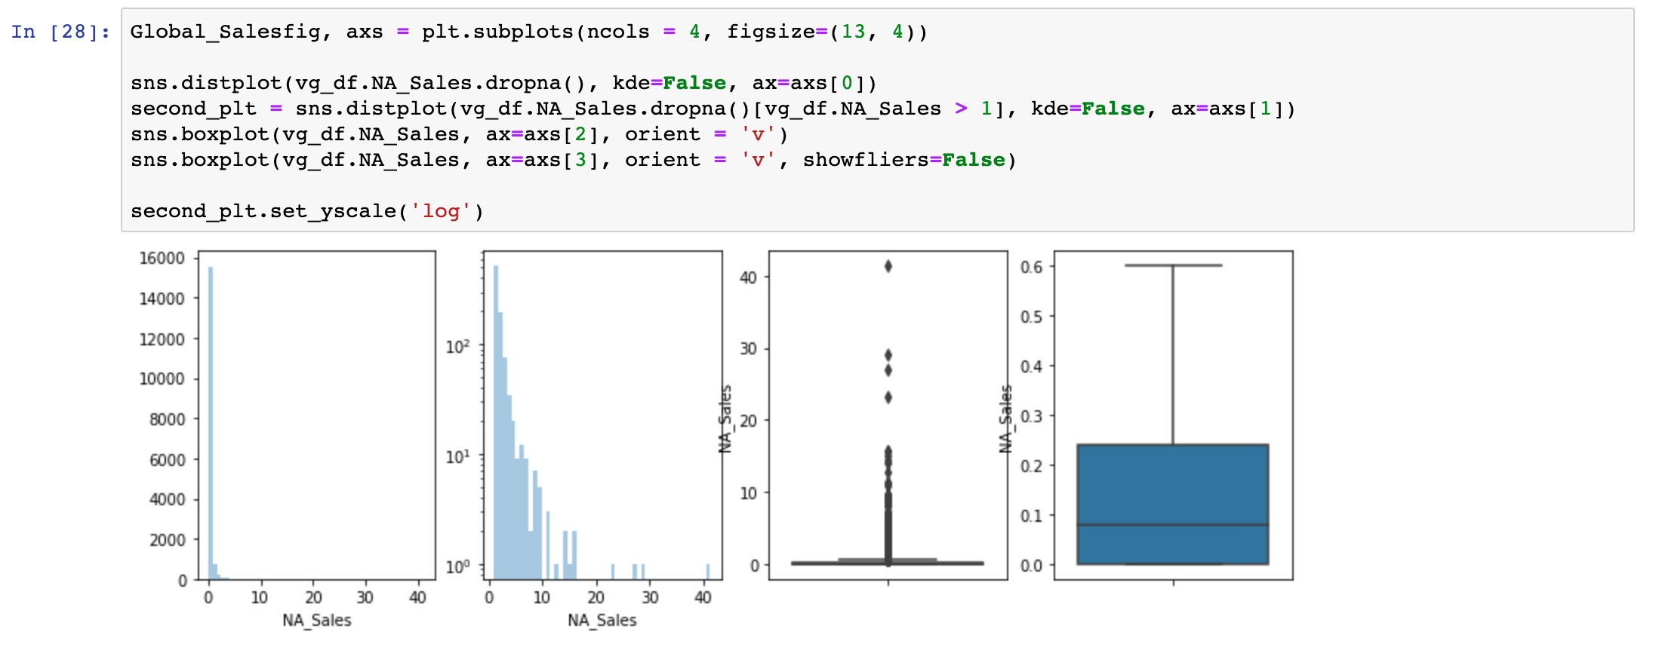

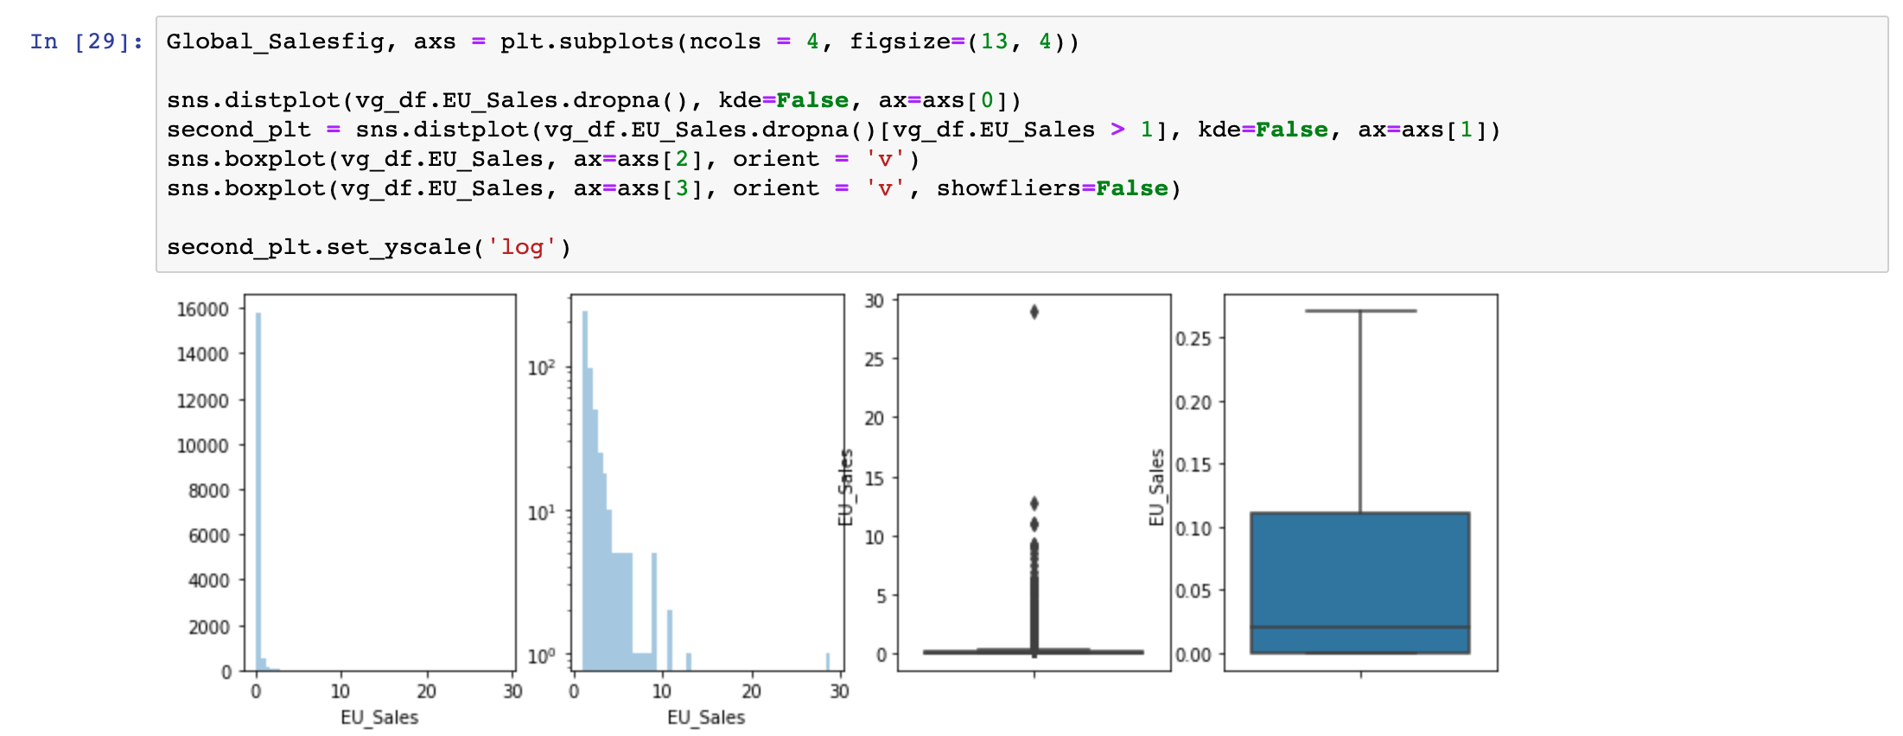

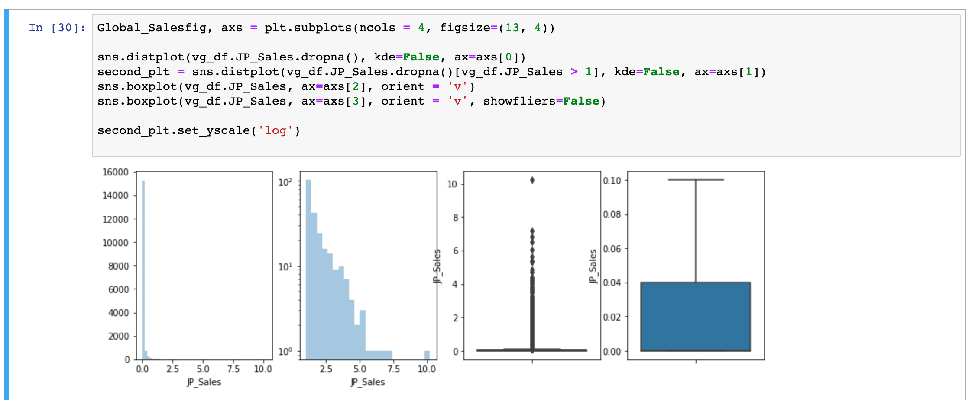

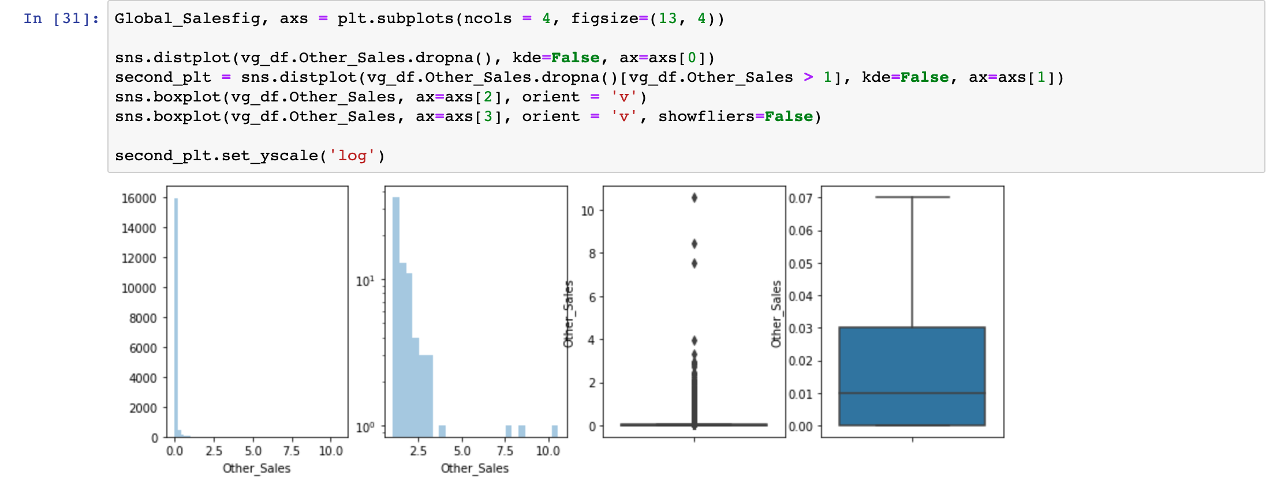

From the above graphs, we decipher that the recurring shape in this dataset is the exponential decay. There are some astronomical sales, then they quickly drop down. Also, for the sales, the sales in North America are the highest - by a good margin, then the European Union, followed by the sales in Japan, then finally the sales in the remaining countries combined.

Next, we visualize the platform sales.

But first, the platform count.

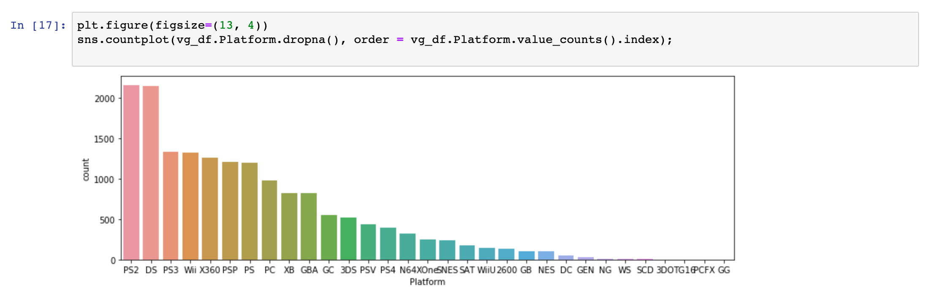

* PS2 and DS beat the rest of the consoles by a huge margin.
* Sony had the highest profits throughout with combined sales from its PlayStation console versions. PS2 and PS3 have 10-year life cycles, as suggested by Sony, which allows gamers to stay committed to Sony, like a subscription.
* Based on number of titles Sony, Nintendo and Microsoft are the major contender.

We assume that PS2 was released in 2000, XBOX and GameCube in 2001. Revenue of PS2 games is the highest. This could be attributed to the fact that PS2 was discontinued in 2013 while XBOX in 2009 and GameCube in 2007.



But we find out that attributing PS2’s larger sales to it being in the market for more time is false. This we find out by adding a condition that shows us the sales between 2000 and 2009.



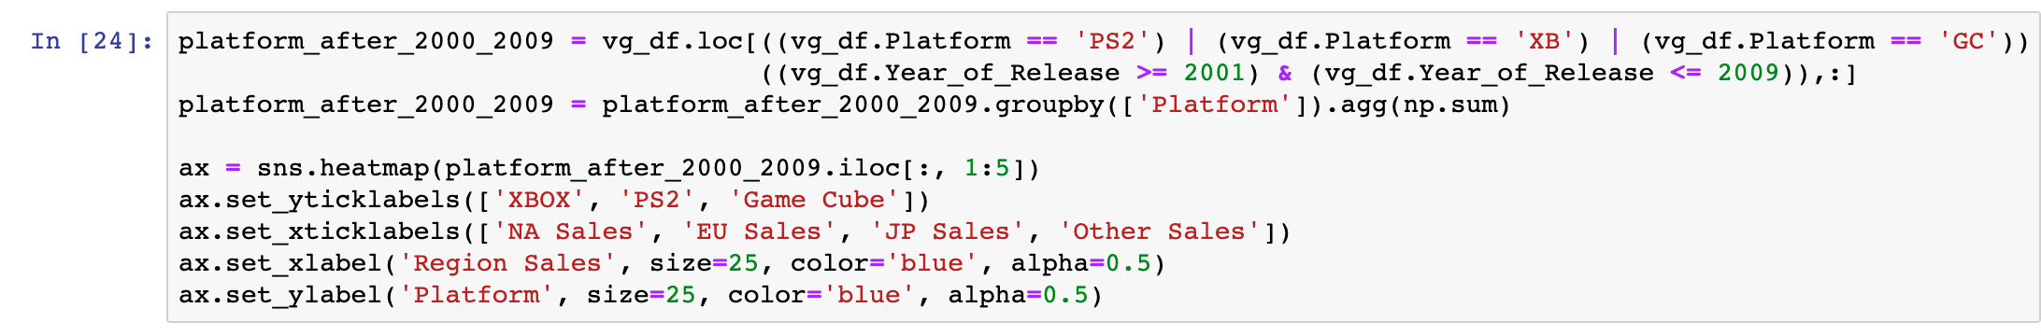

We consider the top three platforms in the dataset. PS2 had maximum sales in NA, which drove the PS2 sales.



Among the top 3 platforms still in continuation, PC takes the lead followed by X360 and then 3DS.PC sales are also driven by NA, more specifically, NA drives the videogame industry sales all over. Here too, Japan has a diverse taste, with its preferred platform being 3DS.

Number of games released based on Genre

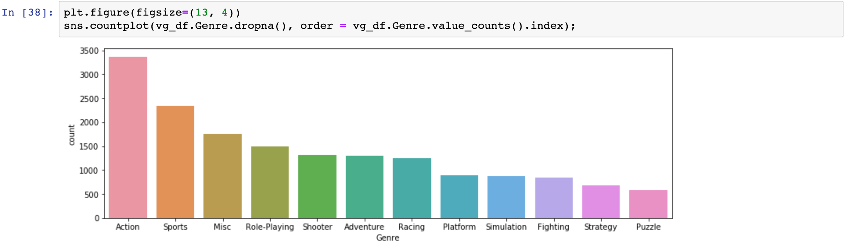

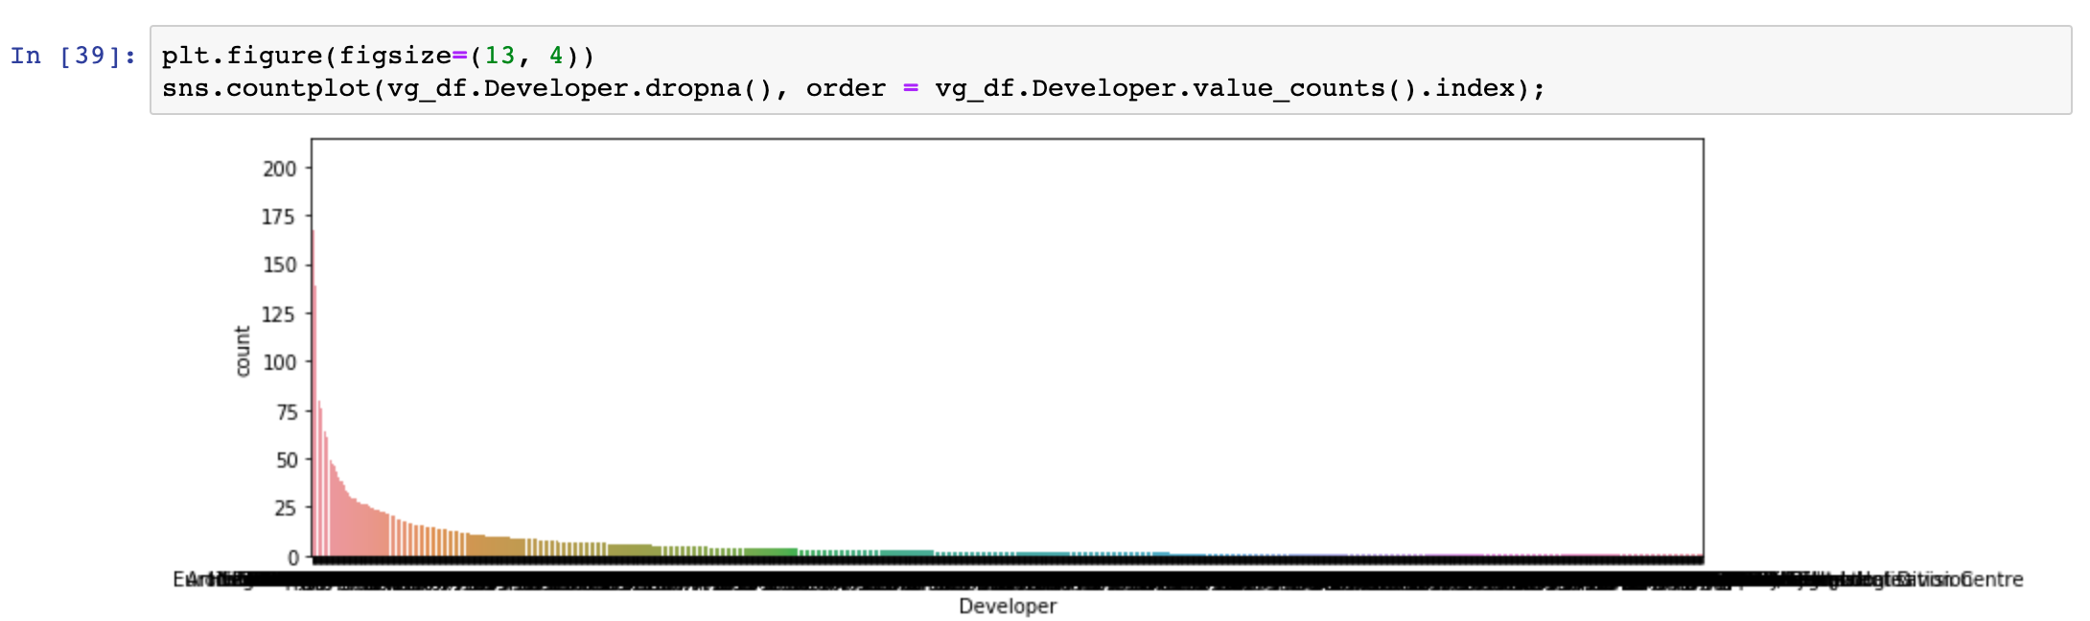

The above graph gives us a count of the number of games based on developers. Although there are too many entries to decipher from, it can be clearly seen that this is an exponential decay too.

So, we reduce the number of entries to 40 for a clearer picture. EA subdivisions are listed separately, else EA would be the top developer based on number of releases.

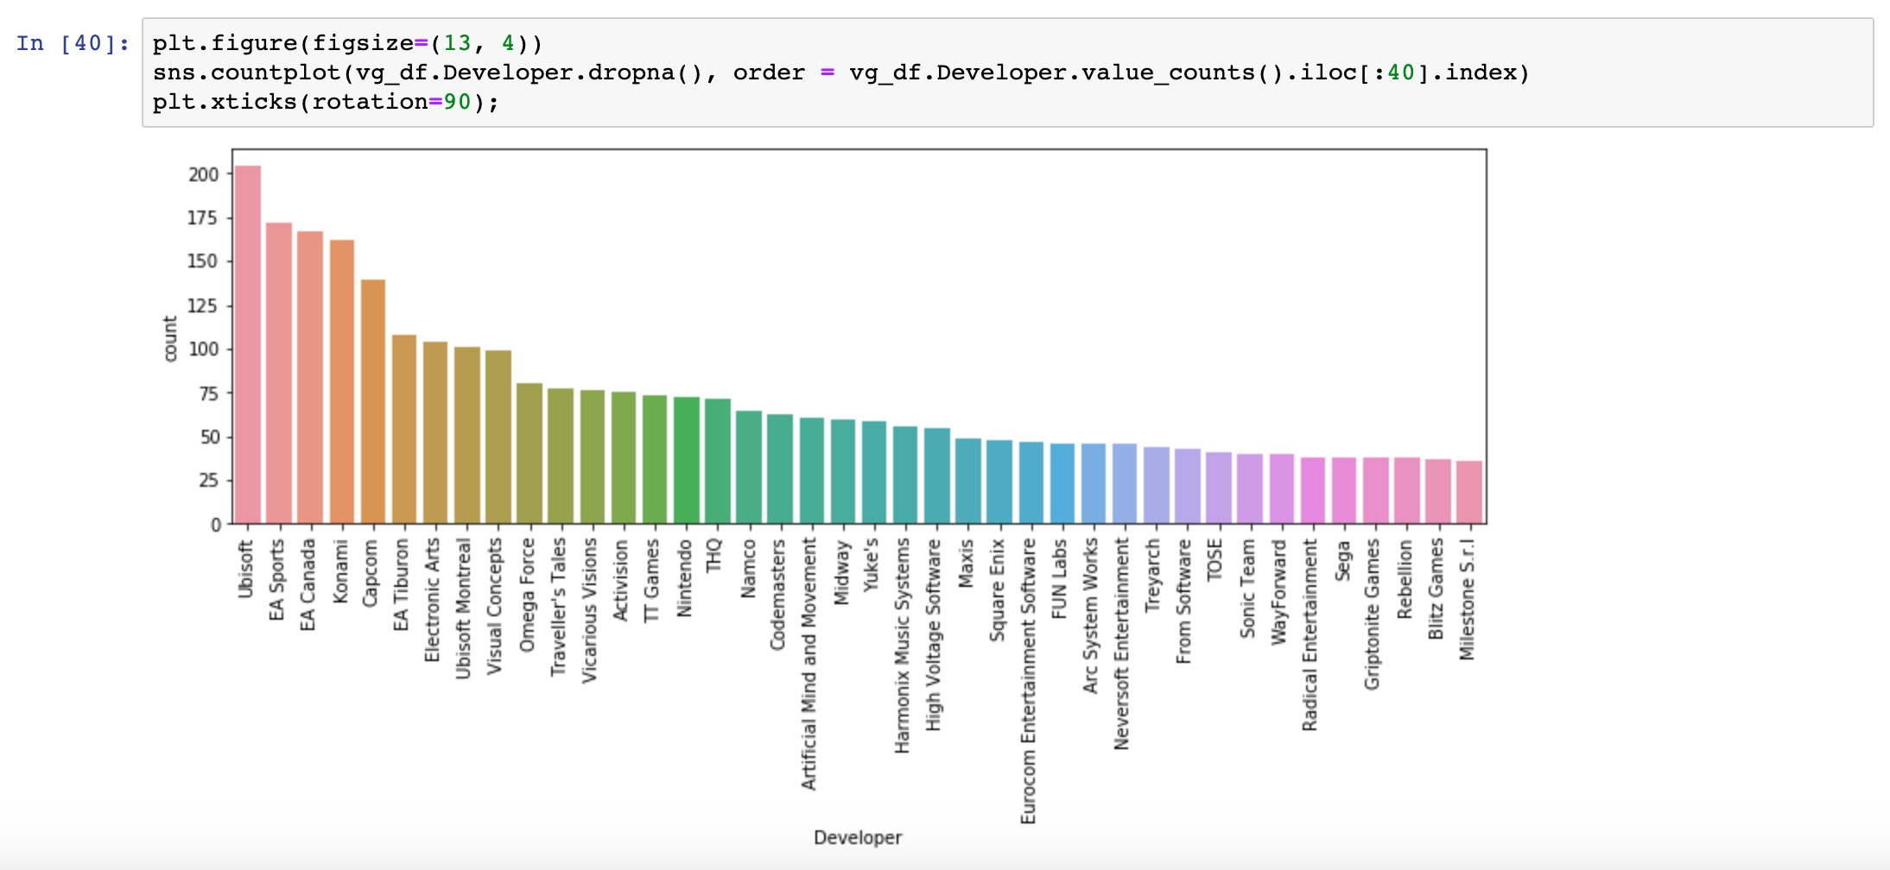

Now, we find out the correlation between the various parameters of the dataset.

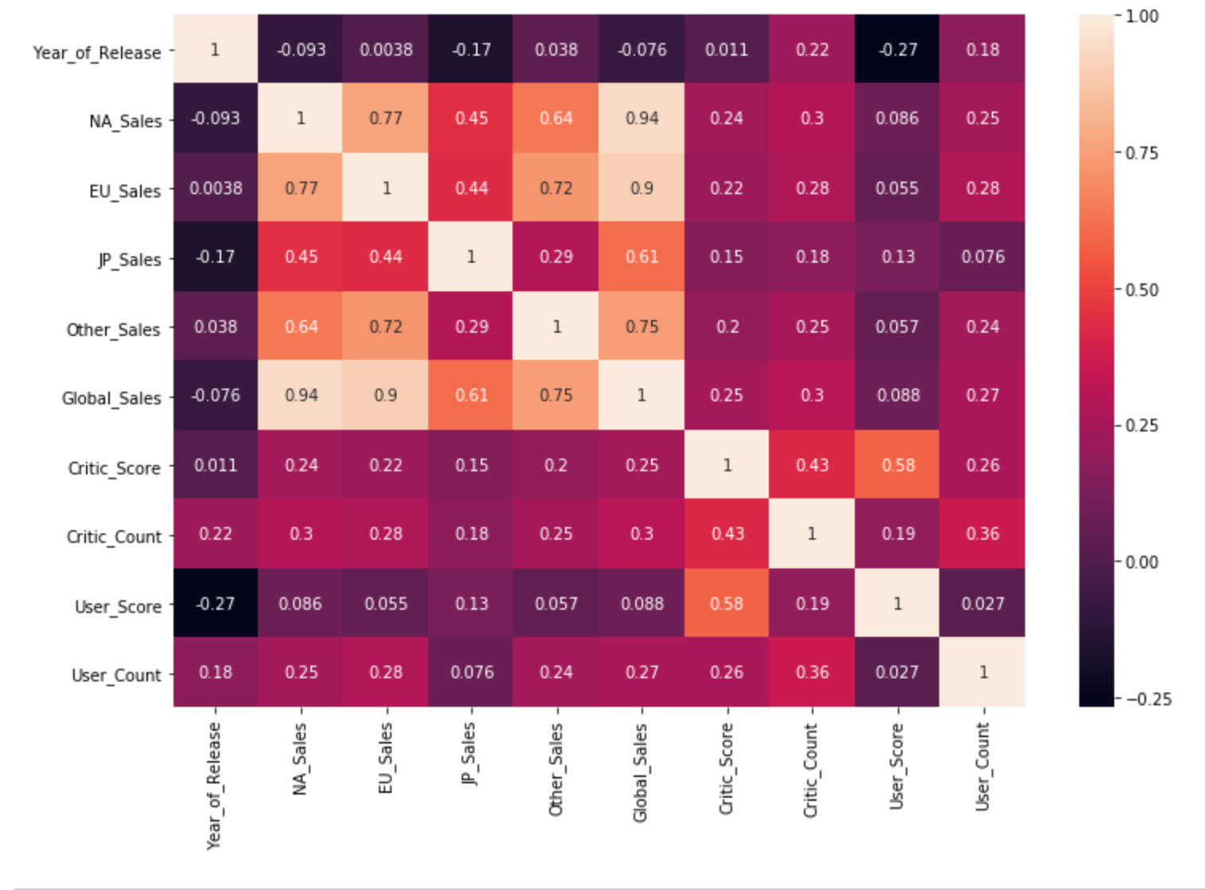

The critic score is more old-school than the user score, but it correlates much better with the sales. In fact, user score does not correlate at all (coefficient almost equal zero) with the games sales.

Area plot : Percentage of sales of each genre  
& sales by year

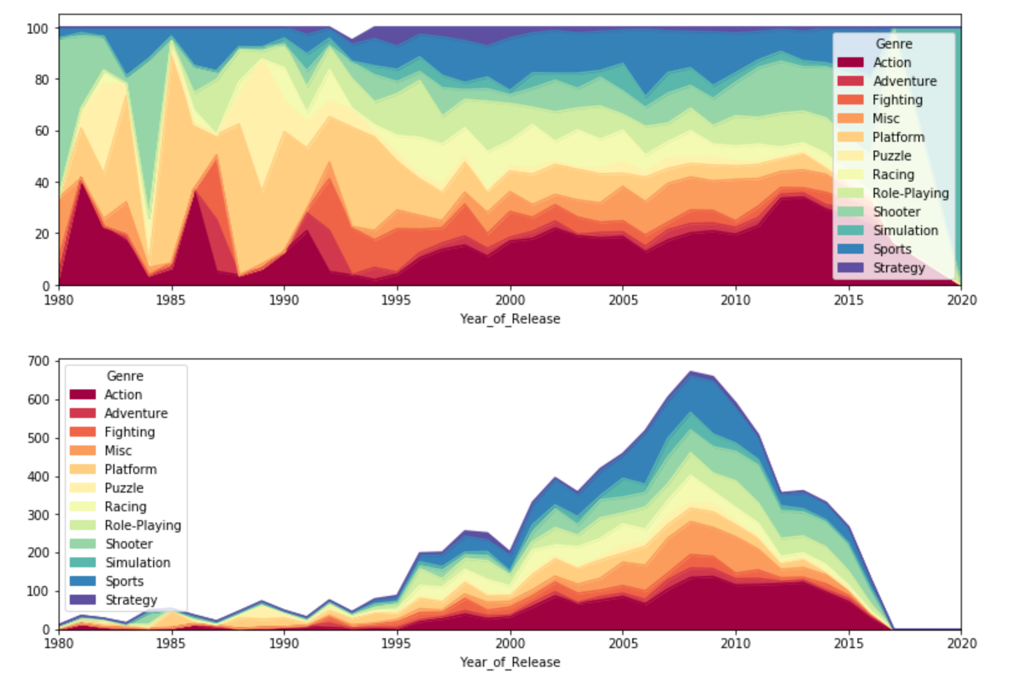

Action genre remained quite unaffected even after the recession in 2009 when game sales started declining. Does this imply the action genre will generate profit irrespective of if it is the most in-demand genre now? We’ll find out ahead.

Total sales based on genre  
shooter, role playing had more sales than releases

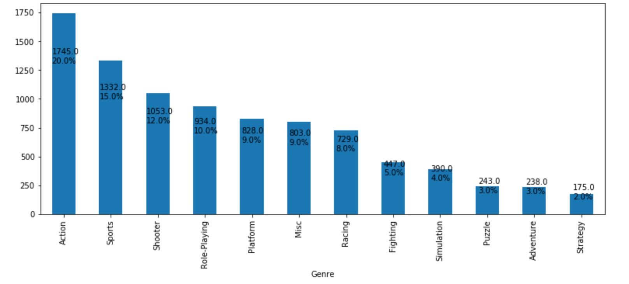

Performance of different genres based on different metrics

SCATTERPLOT OF GLOBAL SALES VS REGIONAL SALES

Sales in Japan follow a different pattern as compared to other regions. Sales in Japan have the lowest correlation to global sales, whereas the NA sales are better correlated to the global sales. If a certain enterprise has a successful venture in NA or EU, there is a high probability of it being successful elsewhere too, except Japan.

Regional sales of Genres

* Sales in Japan points towards a varied taste of genre by Japanese gamers.
* Role playing takes the top spot, but to also be noted is that Action still holds on to the 2nd spot.
* NA, EU and the rest of the world follow a nearly similar pattern.

Top publishers by number of releases, SALES, average yearly earning

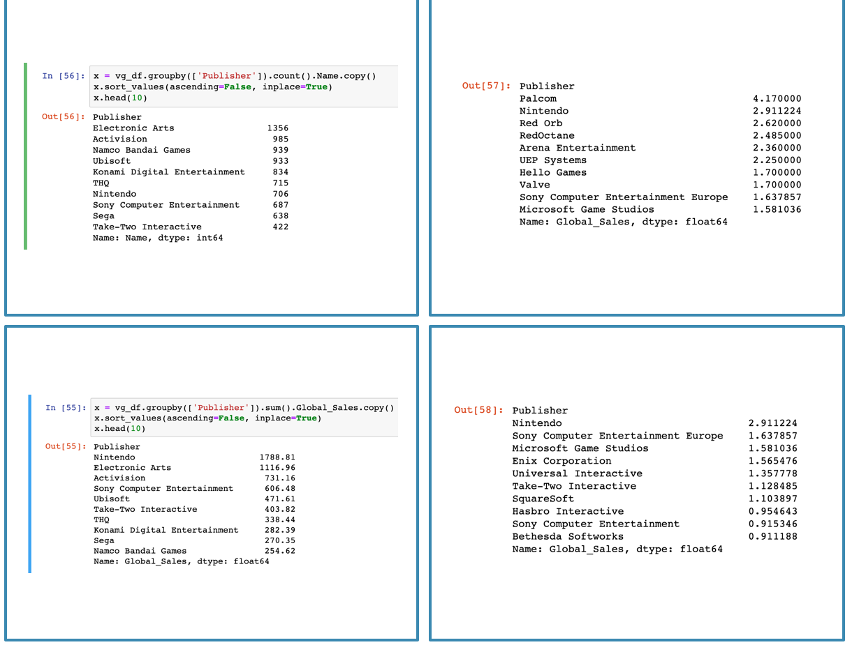

* Publishers in top 10 by sales and number of releases are the same, with different ranking.
* In the average yearly earnings list, a few names are quite unrecognized. Since along with better sales, we also are looking for stability, another condition is added where the company must be in the industry for at least 5 years.
* Like the previous problem, publishers with little publishings making great sales and reappearing on the top list is seen. Another condition of having released at least 10 games before competing for the first places. For example, the first place: Palcom. It is very interesting how, by a good margin, they are well ahead of the rest.

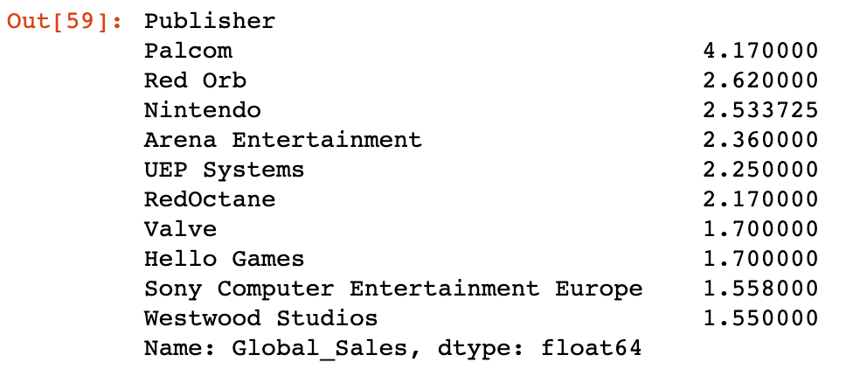

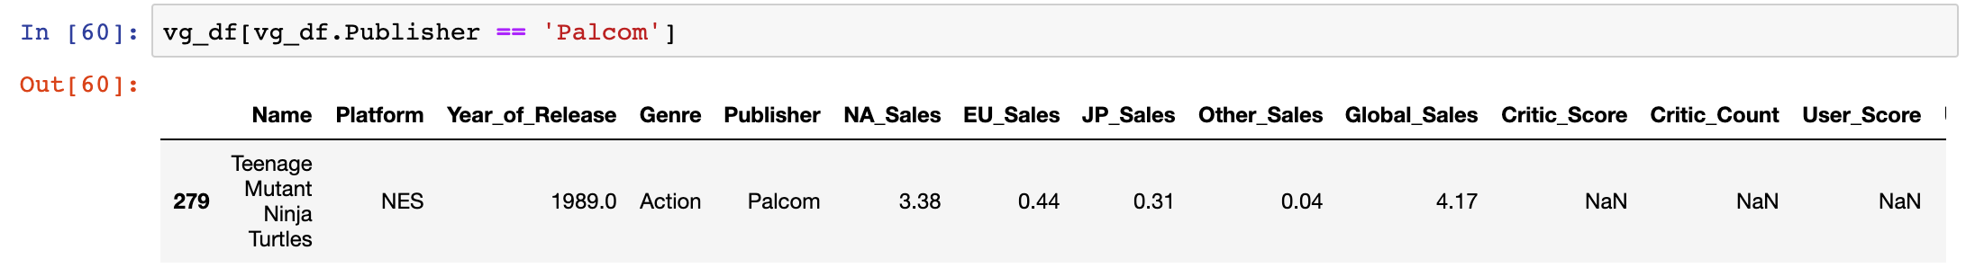

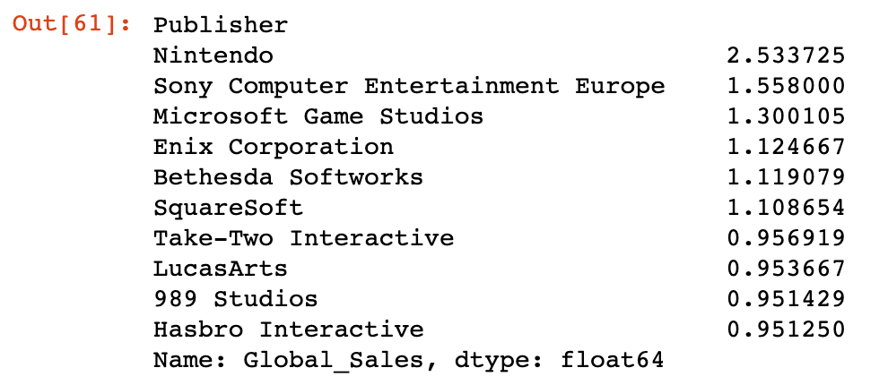

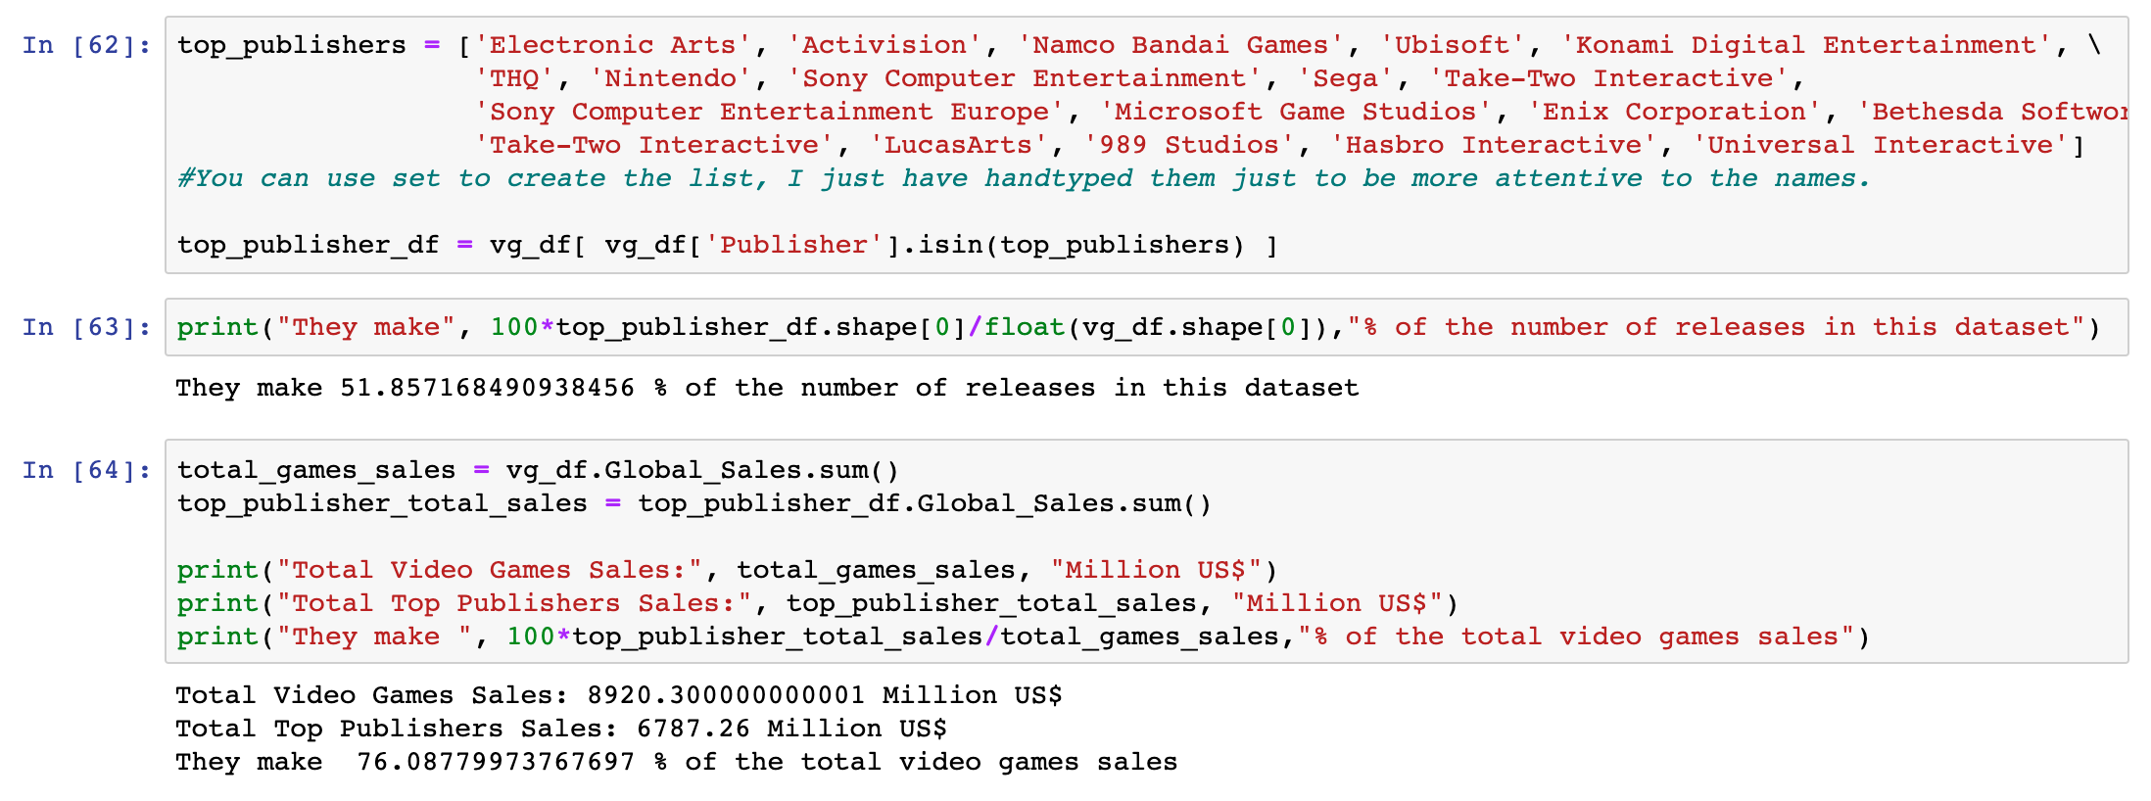

The total percentage of sales occupied by the top companies in the chain.

By number of releases

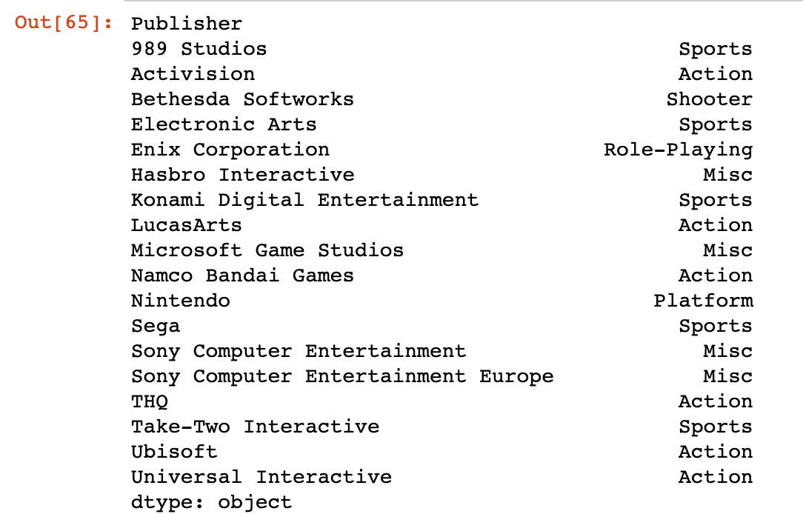

By sales

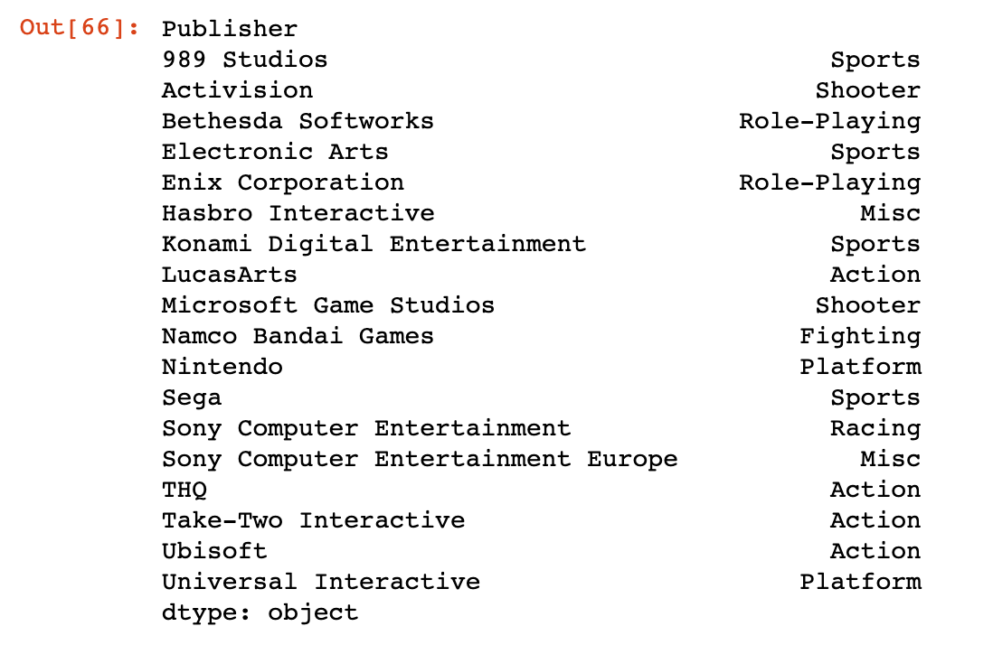

* Companies like 989 Studios, Electronic Arts and Ubisoft earn their maximum revenue from the same genre they release their maximum number of games in. We could call this their bread and butter.
* The companies where this pattern is not seen, it can be assumed that a lot of other external factors may have come to play. It may have happened that although Activision releases more action games, their shooter games are seen to be sold the most, because of a boost in shooter sales in a few regions or for a few years, and not really because their shooter games were better made or liked by gamers throughout.

Top Genre publisher by number of releases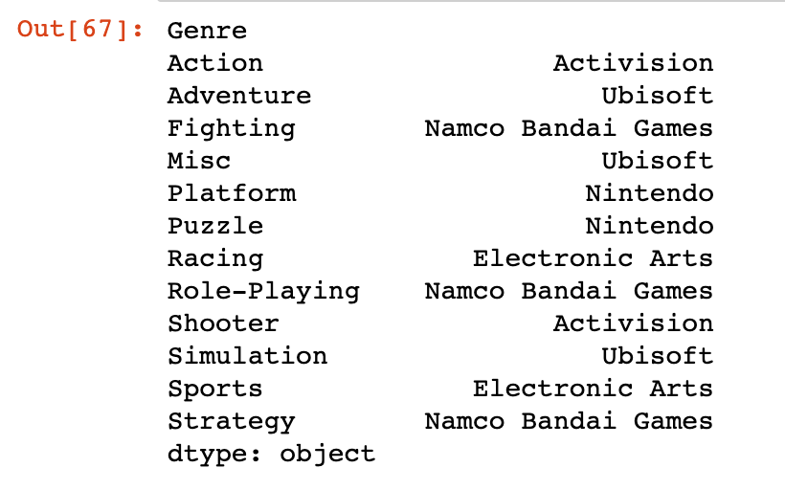

Top genre publisher by sales

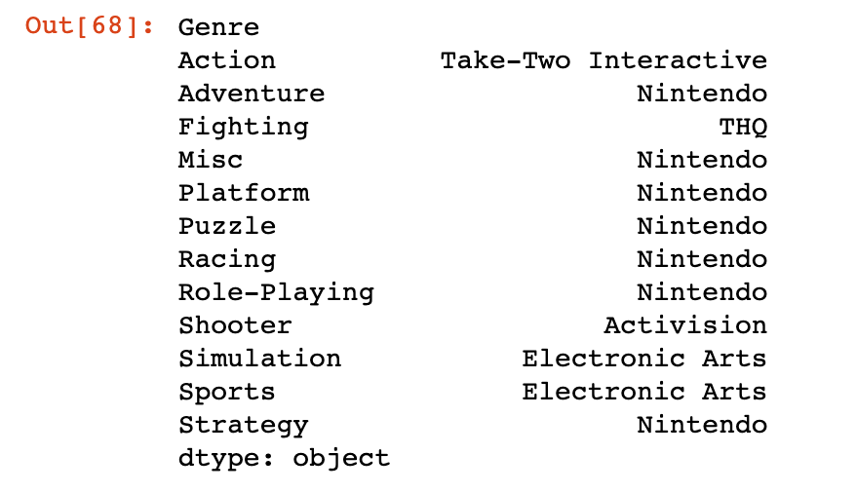

Top genre publishers by average sales per game

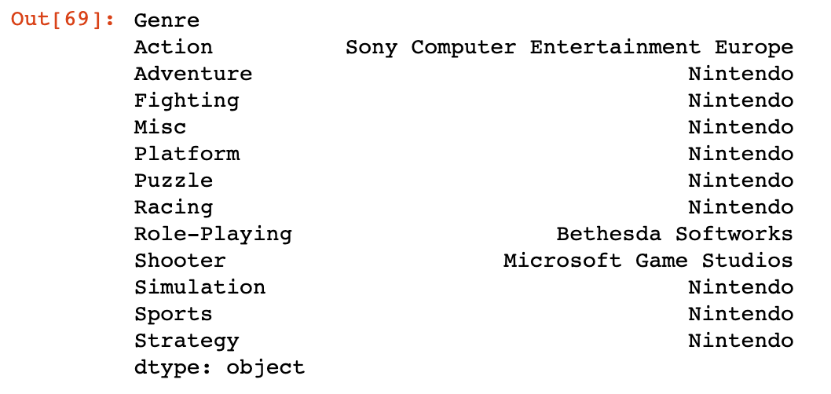

* Activision had the highest action genre releases, but the action genre was dominated in sales by Take-two interactive.
* Activision had the highest sales in shooter genre, and it turns out Activision also has the highest shooter releases.
* Microsoft Game Studios has better average sales per game in the shooter genre, which makes it more profitable in the shooter genre compared to Activision.
* Nintendo is easily seen to be the most profitable company based on sales and average sales per game.

Amongst the three regions with the most sales, NA is contributing the most to the sales.

Top performers by region  
Japan, NA, EU and rest of the world

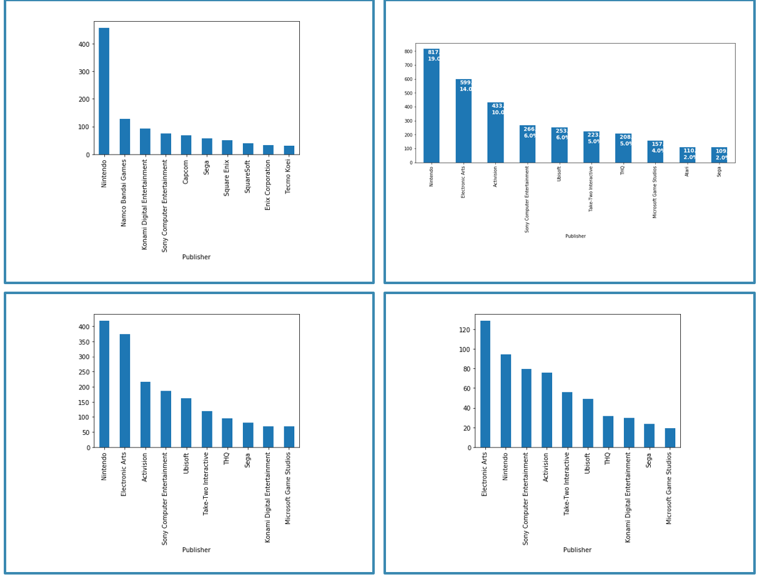

Top genre by region: japan, EU, Rest of the world and NA

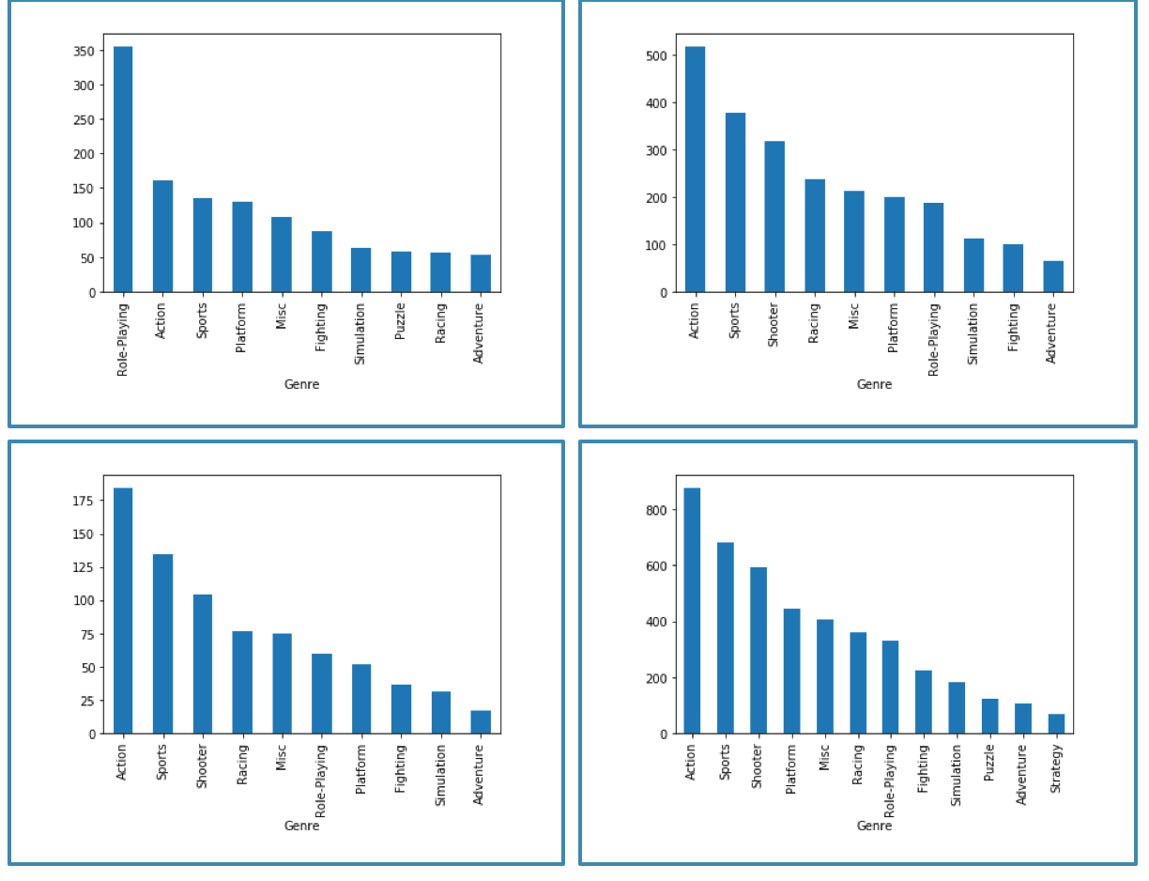

Most profitable games of all time

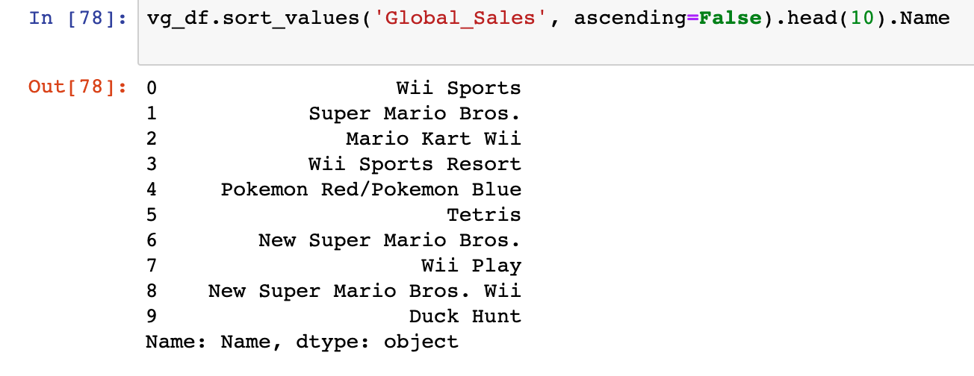

Most profitable games in each genre

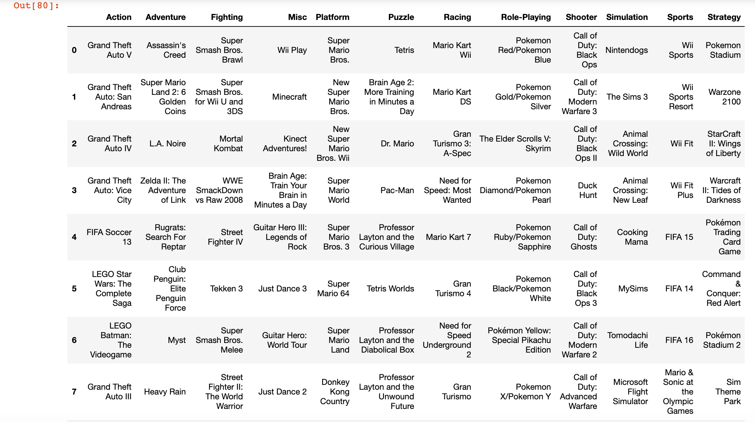

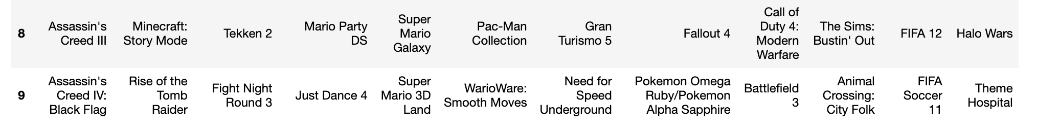

**Conclusion:**

From the above analysis, we can conclude:

* GTA dominates the action genre  
  Wii sports dominates sports, followed by FIFA, basically EA.  
  Call of Duty dominates the shooting genre, produced by Activision.  
  The dataset need some cleaning, for example FIFA 2013 is listed as an action game while the rest of the FIFAs are listed as sports. Same for Assassin's Creed, some are listed as Action, others are adventure.
* The sales and the number of releases go hand by hand, as expected.
* The "Action" genre seems to be the most resistant to sales decline
* Genres follow the expected pattern when we compare their number of releases and their revenues. However, when we add to the picture the average revenue per game, the rankings change a lot:
* Japan is a unique region when it comes to games. The rest of the world is consistent, but Japan is different
* The Japanese also showed a strong inclination to Nintendo as a publisher, and for the "Role Playing" genre.

The top publishers list is a list made of the top 20 publishers that consistently made it to the top 10 lists of different metrics (e.g. top selling games, top total sales..etc)

* The top publishers are:  
  Electronic Arts  
  Activision  
  Namco Bandai Games  
  Ubisoft  
  Konami Digital Entertainment  
  THQ  
  Nintendo  
  Sony Computer Entertainment  
  Sega  
  Take-Two Interactive  
  Sony Computer Entertainment Europe  
  Microsoft Game Studios  
  Enix Corporation  
  Bethesda Softworks  
  SquareSoft  
  Take-Two Interactive  
  LucasArts  
  989 Studios  
  Hasbro Interactive  
  Universal Interactive
* These 20 companies make up a little over half (51.85%) of all the games produced, and a little over three quarters (76%) of all the global sales. Exponential decay pattern can be seen everywhere.

Exponential decay: A quantity is subject to **exponential decay** if it decreases at a rate proportional to its current value.

As an example, let us consider,

* If Apple decides to foray into the videogame industry, specifically Japan, it’ll first eye the role-playing genre as that has the largest sales in Japan.
* It’ll face stiff competition from Nintendo, which not only has the maximum sales in Japan, but also is the largest publisher of role-playing genre globally. Also, Bethesda Softworks has the best average sales per game, for the role-playing genre. And because role-playing genre ranks 1st in Japan but falls 5 ranks at least in other regions, a large chunk of Bethesda’s profits arrive from Japan.
* Since the action genre ranks 2nd in Japan and 1st globally, Apple could mitigate the risk of trying to battle it out with Nintendo for a large share in Japan and instead stick to the action genre. The action genre was also unaffected by recession and is always in demand. But quantitatively, the action sales in Japan are very less compared to role-playing genre. Based on the dataset, 3DS platform is the most used in Japan. Apple can focus their R&D on developing games specifically for 3DS only to penetrate the Japanese market. With a few more critical variables and depending on the timing and scenario of the game launch, Apple can further analyze and decide if it wants to break ground in Japan, and if it does, what would be the best time and method to do so.

The following links were used as references and as vital information in completing the project.

* <https://www.kaggle.com/etakla/exploring-the-dataset-univariate-analysis>
* <https://www.cnet.com/news/global-video-game-sales-fell-7-percent-in-2009/>
* <https://www.kaggle.com/etakla/exploring-the-dataset-bivariate-analysis>
* <https://www.economist.com/business/2010/03/25/still-playing>
* <https://www.kaggle.com/rush4ratio/video-game-sales-with-ratings>
* <https://www.researchgate.net/post/While_doing_univariate_and_multivariate_analysis_which_is_more_reliable_Odds_ratio_or_P_value>
* <https://www.kaggle.com/maxkliment/video-games-predicting-global-sales>
* <https://www.businessinsider.com/video-game-industry-120-billion-future-innovation-2019-9>
* <https://www.kaggle.com/jruots/forecasting-video-game-sales>
* <http://halweb.uc3m.es/esp/Personal/personas/dpena/publications/ingles/2007JTSA_sanchez.pdf>